NORTH EAST RECYCLING FORUM

29th September 2022
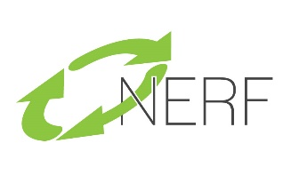
10am – 1.30pm
Tyneside House
Newcastle Business Park
Newcastle Upon Tyne
NE4 7AR

A G E N D A

10.00am Registration, Coffee and Networking

10.30am Jeff Moffitt, Chairman Welcome

10.40am Hugh Sheldon, HSBC – Sustainable Finance

11.00am Nigel Tomlinson, Valpak – Vape & Battery Recycling

11.20am Coffee and Networking

11.40am Dr Wendy Fail, Northumberland County Council - Waste
Awareness Education

12.00pm Jo Holmes, Genee Consulting Ltd – NEECCo Waste and Resources Planning Group

12.20pm Questions and Discussions

12.35pm Lunch and Networking

1.30 Meeting Close

